**2. SPRİNT GÖRÜNTÜLERİ**

* **20.06**

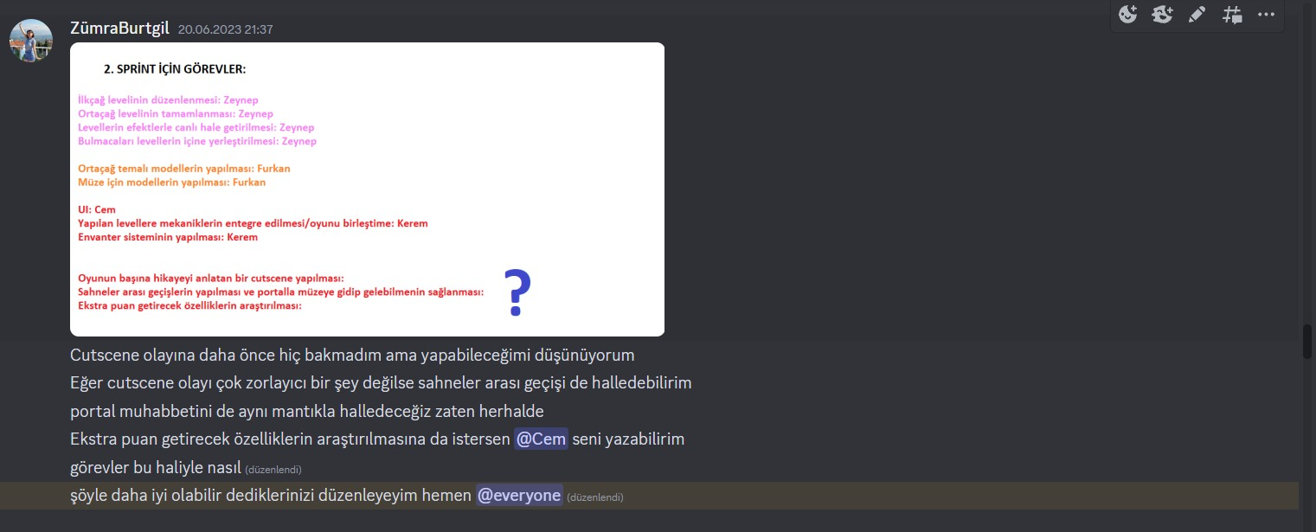

* **22.06**

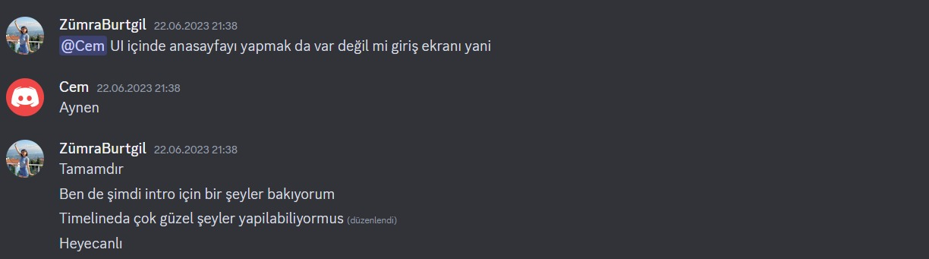

* **23.06**

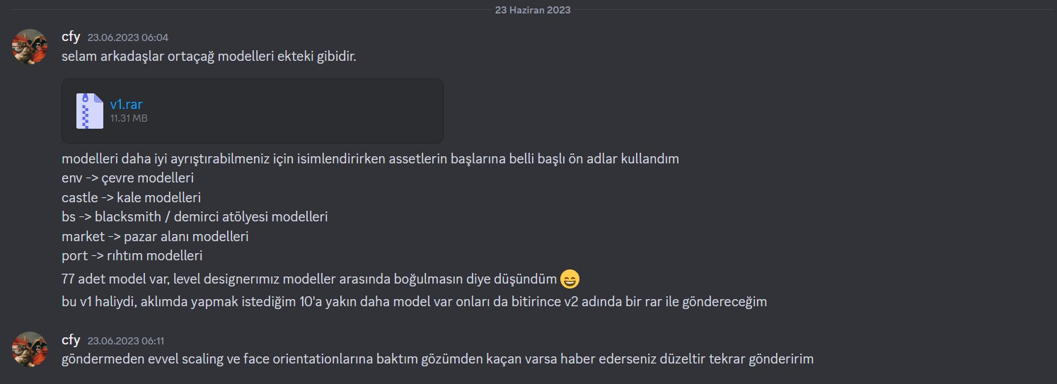

* **24.06**

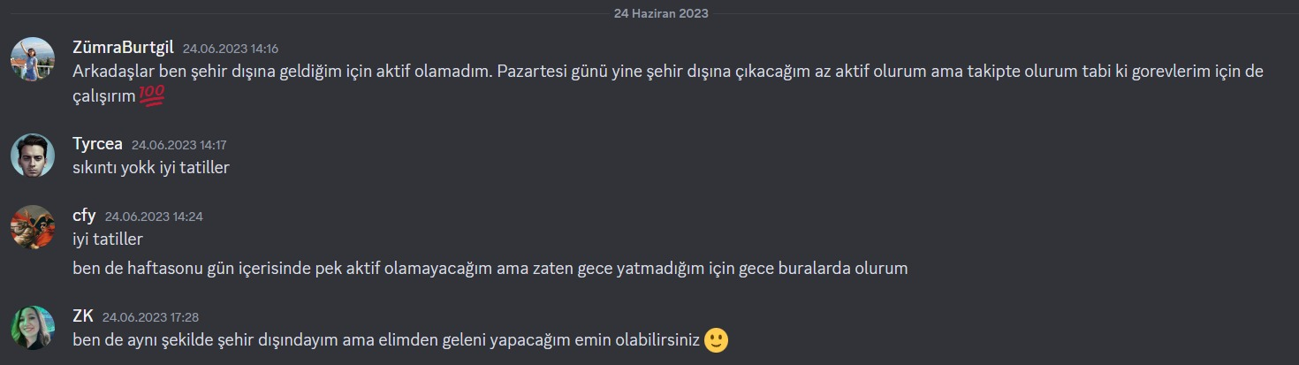

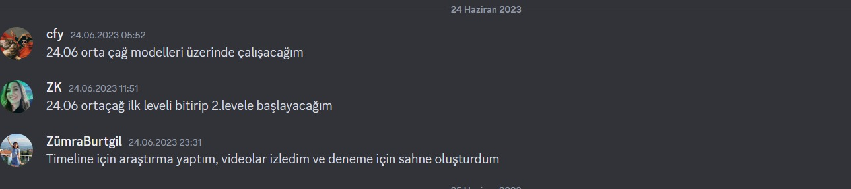

* **25.06**

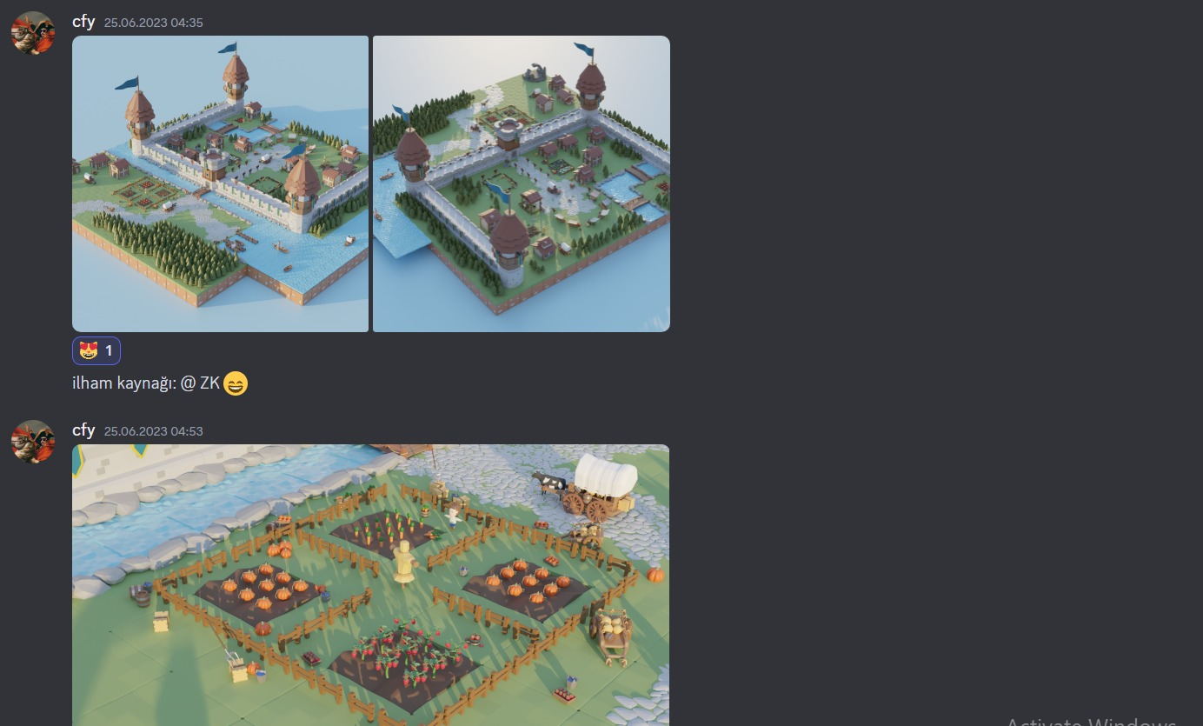

* **26.06**

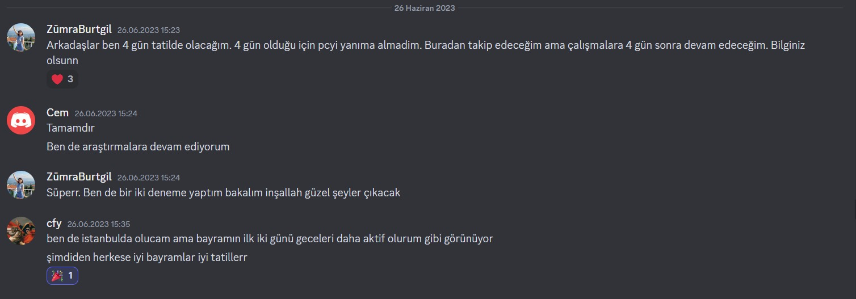

* **27.06**

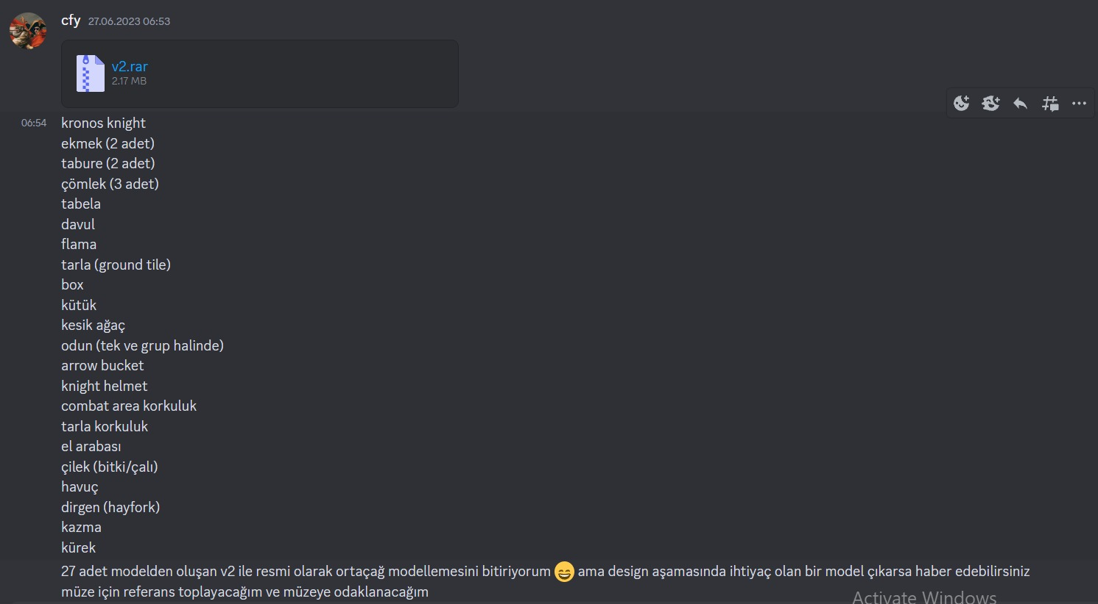

* **29.06**

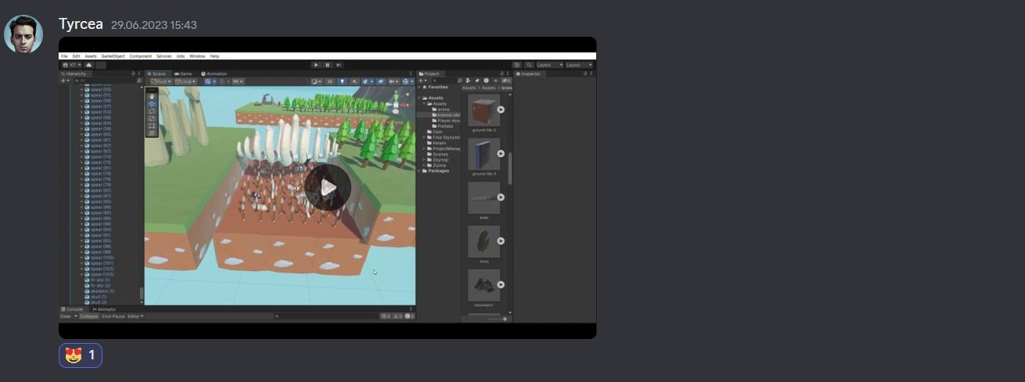

* **01.07**

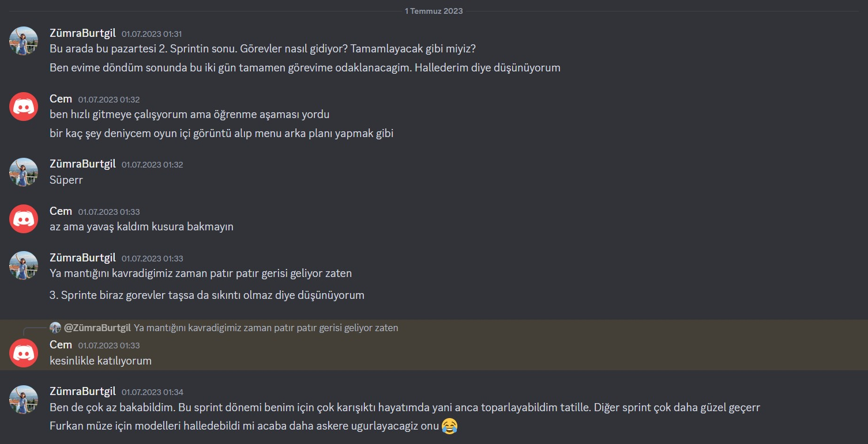

* **02.07**



